**4. Mini-Test**

1. With Vector Clocks you can differentiate between events which may occur in different processes.





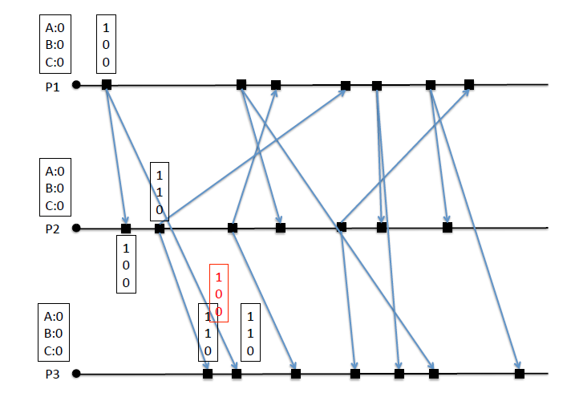

200

220

220

320

4201

430

1  
2  
0

120

230

430

330

120

230

330

330

430

100

110

110

200

100

220

120

230

320

420

420

100

320